CS7646: Project 1 - Martingale

Marcus Anderson  
manderson332@gatech.edu

***Abstract—***In this report, I present the findings I received from building my own Simple Gambling Simulator. The simple and realistic simulators I constructed simulate 1000 successive bets based on the probability of betting only on “black” using the American roulette wheel. By referencing the Roulette wiki page, I was able to deduce the probability of a player hitting a “black” bet successfully was around 47%. This was calculated by taking the number of black pockets divided by the number of total pockets in an American Roulette wheel (18/38 = 0.47). This probability was then factored into the simulators that ran multiple episodes, each consisting of 1000 successive bets, and the results were analyzed and plotted on five separate graphs. The aim of the project was to provide a realistic simulation of the betting strategy and to evaluate its performance over multiple episodes. These simulators can be used as tools for understanding the potential outcomes of this specific betting strategy and can even be applied to real-life gambling.

**1 INTRODUCTION**

Viva Las Vegas! One of the only places where a player can either become a millionaire or lose whatever sock money they bought with them for the weekend in one night. Welcome to my report on assessing the performance of a popular betting strategy for American roulette. As a fan of gambling, and avid loser, I was fascinated by the idea of using a betting strategy to potentially increase my chances of winning. I was tasked to conduct two experiments to simulate this strategy, while plotting the results in various figures, and see how it performs under different conditions.

In the first experiment, I used Professor Balch's original betting strategy and simulated it using the Monte Carlo method by implementing the pseudocode shown in the project wiki. This simulation was ran multiple times with randomized inputs and stored the results in a collective *numpy* array. The twist to this experiment was that once the target number of $80 winnings was reached, the player seized betting and backfilled the remaining array with a value of 80. I also created three figures charts that visualized the performance of the strategy over the course of ten and one-thousand episodes.

In the second experiment, I was tasked to make a more realistic simulation by introducing a limited bankroll of $256 using the same logic as the original simulator. This meant that when a player ran out of money, they seized betting and backfilled the remaining numpy array with a value of -256. The player also had to keep in mind that if they only had a certain amount of money remaining, but the next bet amount using the Monte Carlo strategy was higher, they could only bet their remaining amount of money. The goal of this experiment was to see how the strategy performs when the player has limited resources to gamble with. I created two additional figures to display the performance of this simulation over the course of one-thousand episodes.

**2 QUESTIONS**

* 1. **Question 1**

In order to calculate the estimated probability of winning $80 within 1000 sequential bets using the simple simulation, I first needed to use the estimated probability formula, which equals the number of successful outcomes divided by the total number of possible outcomes (**Estimated Probability = (Number of successful outcomes) / (Number of total outcomes)**) (Indeed Editorial Team, 2020).

My next action item was to use the estimated probability formula to calculate the probability that the simulated player would win $80, the successful outcome, within 1000 bets, the total number of outcomes. To make this easier, I create a simple helper function in Python that parsed though my winnings array returned by the simple simulation. This function checked if the final winnings within an episode equaled 80, and if it did, the episode counted as a successful outcome.

I ran this function for both the ten and one-thousand episode arrays, and to my initial surprise, they both came back with a 100% probability! However, after some thought, I realized a couple factors that could cause this perfect probability. One factor is that it’s easier to reached $80 in winnings within such a high spin count such as 1000. I tested this theory by reducing the total number of spins in my simulator and the probability went from 100% to 6.7%. The other factor I thought of was increasing the successful outcome value within the high spin count. By bumping up the probability of winning $80 to $500 within 1000 spins, the probability came in at 2.9%. Moral of the story, “more betting + lower cutoff = higher chance of winning”.

**1.2 Question 2**

To find the expected value of winnings after 1000 sequential bets I knew I needed to use the expected value formula provided by the project wiki (**Estimated Value = Σ (Probability of Event x Value of Event)**). By referencing the previous question, I know there’s a 100% probability that a player going through the simple simulator will win $80 per episode (1000 sequential bets). I multiplied the probability percentage, 100%, by the event value, $80, and reached the expected value of $80 for this simulation. This makes the most sense because the player wins $80 every episode by cutting themselves off from betting once reaching this amount.

**1.3 Question 3**

In regards to the first part of this question, based on the graph below, Figure 1, I can see that the upper standard deviation line does not reach a maximum or minimum value and then stabilize. This is because the upper standard deviation has a minimum value of 0 and a maximum value of 2042, which allows for a wide range of values. On the other hand, I see that the lower standard deviation line does stabilize at the maximum value of 80. This is apparent because while the lower standard deviation also has a minimum value of 0, it maxes out at 80, at which point the “Winnings” start to stabilize, as seen in the figure.

For the second part of this question, the standard deviation lines do end up converging at spin number 215, which I was able to confirm this by looking at the numpy array calculations. This is because the simulated player reaches their goal of $80 and stops betting on future spins. At this point, the value of 80 is constant after spin number 215, and the mean for every spin afterwards becomes 80, making the standard deviation for each spin equal 0. This causes all three lines to meet at 80 (80 + 0 =80 and 80 - 0 = 80).

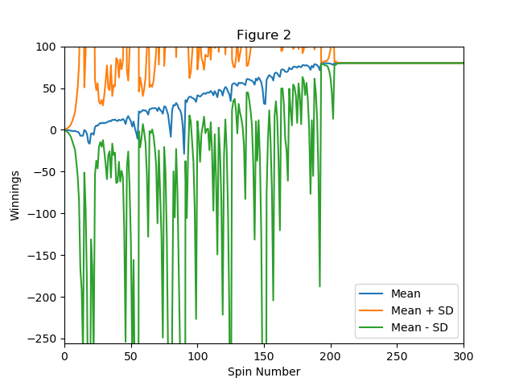

*Figure 1—Generated graph from simulation results. This graph shows the mean, upper standard deviation, and lower standard deviation for Experiment 1*

**1.4 Question 4**

Much like the first question, to find the estimated probability of a player winning $80 within 1000 sequential bets using realistic simulator, I needed to use the estimated probability formula. With the assistance of my simple helper function, it appears that the estimated probability of a player winning $80 within 1000 sequential bets over the course of 1000 total episodes comes to about 62.2%.

A main reason for the drastic difference in probability between Experiment 1 and Experiment 2 is likely due to the limited bank roll amount of $256 per episode. When the simulated player has a limited bank roll, it becomes much harder to reach their $80 goal, as they must stop betting once they lose all of their money. In addition to the bank roll introduction, the player also was not allowed to bet more money than they had on hand. If the next bet is supposed to be $64, but a player has only $20 remaining, that’s all they could bet for that spin. This makes it nearly impossible to reach the $80 goal in a lot of episodes, because once the player approaches their bankroll limit, it’s harder to dig out of that hole.

However, even with the introduction of a bank roll, I saw that a player can still win $80 in about 3/5's of 1000 total episodes, which is a noteworthy probability. This means that even with a limited bank roll, a player has a reasonable chance of winning $80 within 1000 sequential bets. That’s nothing to sniff at!

With a limited bank roll, a player's strategy may have to adjust to the amount they have. They may need to bet less or use an alternative strategy in some cases that allows them to maximize their odds of winning. While a player with an unlimited bankroll can afford to take more risks, allowing them to have higher chances of winning.

**1.5 Question 5**

Similar to the second question, to calculate the expected value of the player betting through my realistic simulator, I need to use the expected value formula. Again, using the formula coupled with my probability helper function, the estimated expected value of winnings after 1000 episodes (1000 sequential bets per episode) is -$169.84. I came to this result by calculating the sum of the products of the expected values (winning amounts) and their respective probabilities. In this case, the outcomes are the winnings of $5 and $80, as well as the loss of $256, with probabilities of 0.622, 0.001, and 0.377. respectively (E(x) = (.622 * 80) + (0.001 * 5) + (.377 * -256)).

By calculating the expected value of the winnings, we can see that the player has a 62% probability of winning $80, a 37.7% chance of losing all of their money, and a 1% chance of winning only $5 over the course of 1000 episodes. This means that the simulated player is expected to lose about 68% of their total bankroll in Experiment 2, opposed to being guaranteed $80 in Experiment 1.

**1.6 Question 6**

Unlike Experiment 1, in Experiment 2 it appears that the upper and lower standard deviation lines do not reach a maximum or minimum value and then stabilize. Additionally, it looks as if the standard deviation lines do not converge as the number of sequential bets increases according to the graph in Figure 2.

The reason for this is that in Experiment 2, the player has a chance to lose all of their money each episode, which makes their results more fluid. As the player continues to bet, they start out winning $80 in earlier episodes, but gradually start to lose all of their money more frequently in later episodes. This means that as the number of sequential bets increases, the standard deviation lines continue to stretch away from the mean line in opposite directions, rather than converging towards it.

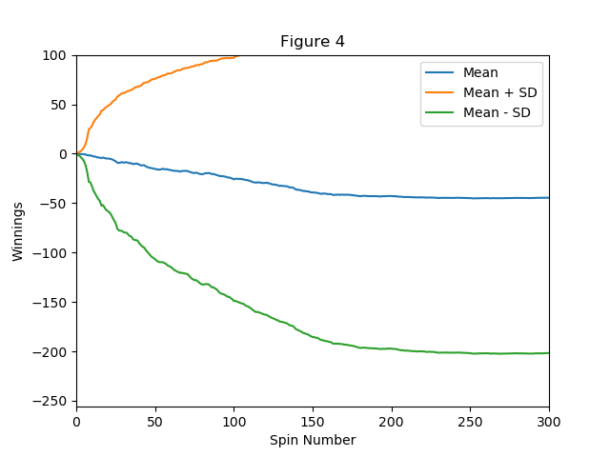

*Figure 2—Generated graph from simulation results. This graph shows the mean, upper standard deviation, and lower standard deviation for Experiment 2*

I believe since the results in Experiment 2 are more fluid and the player has a chance to lose all of their money each episode. This means that there is a higher degree of variability in the winnings per episode, which results in the standard deviation lines continuing to stretch away from the mean line.

**1.7 Question 7**

When conducting experiments, using expected values can provide a more accurate and comprehensive understanding of the possible outcome of said experiment, rather than relying on the result of one specific random episode.

A few benefits for using expected values would be:

1. **Long-term prediction power:** Provide a long-term prediction of the outcome of an experiment, rather than a snapshot of one specific random episode. Allowing a better understanding of overall trends.
2. **Incorporating all various outcomes:** Combines all possible episodes, instead of focusing on one specific episode. This allows for a more complete understanding of the experiment as it includes both positive and negative potential outcomes.
3. **Outcome averages:** Expected values take into account all possible outcomes as well as their respective probabilities. The various results are then averaged, which provides a more accurate depiction of the expected outcome.

For example, in Experiment 2, the results were dynamic, with a 62.2% chance of seeing an $80 outcome, 37.7% chance of a -$256 outcome, and 1% chance of a $5 outcome. Therefore, if we were only to look at the result of one specific random episode, we would not get a full picture of the likely outcome of a player using the realistic simulator.

Expected value is a measure of how much the player is expected to win or lose in the long run. This value can be positive or negative, and is not the most likely outcome. Instead, look at it as an educated guess of how the player is expected to win or lose in the long run.

**3 ADDITIONAL GRAPHS**

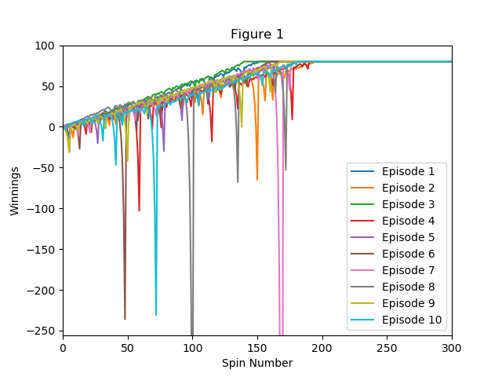

*Figure 3—Generated graph from simulation results. This graph shows the winnings of each spin across 10 different episodes for Experiment 1*

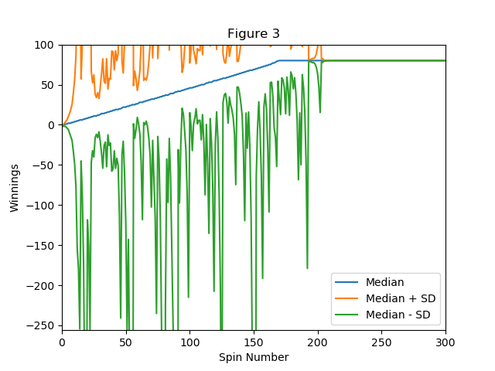

*Figure 4—Generated graph from simulation results. This graph shows the median, upper standard deviation, and lower standard deviation for Experiment 1*

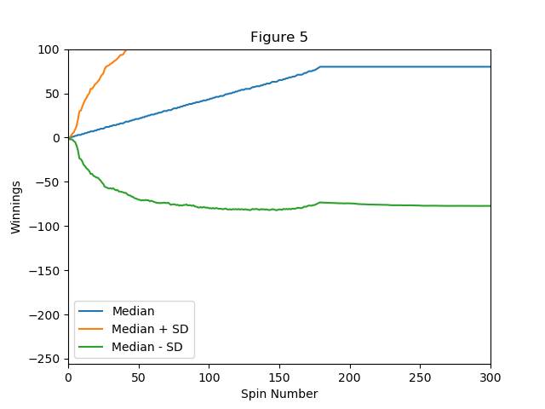

*Figure 5—Generated graph from simulation results. This graph shows the median, upper standard deviation, and lower standard deviation for Experiment 2*

**4 CONCLUSION**

In conclusion, this report presents a detailed analysis of a well-known betting strategy used in American roulette and its performance under different conditions. The results of the two conducted experiments demonstrate the effectiveness of the strategy in increasing the chances of winning.

The first experiment, which simulated the betting strategy with a target number of $80 winnings, showed positive results. The figures created to visualize the performance of the strategy over the course of ten and one-thousand episodes also reinforced its effectiveness when there are little to no restrictions.

The second experiment, which introduced a limited bankroll of $256, provided a more realistic simulation of the strategy. The figures created to display the performance of this simulation over the course of one-thousand episodes showed that the strategy still performs well, with over a 60% win rate, even under the constraints of limited resources.

Overall, I’ve demonstrated that the use of a betting strategy can be beneficial for players, even when we bring in real world constraints. Funny enough, I’ve actually tried this exact method out myself during my last trip to Vegas and won about $5. So even I can attest to its legitimacy!

**5 REFERENCES**

1. Indeed Editorial Team. (2020, February 25). How to Calculate Probability. Indeed Career Guide. <https://www.indeed.com/career-advice/career-development/how-to-calculate-probability>
2. Roulette. (2020, February 14). Wikipedia. <https://en.wikipedia.org/wiki/Roulette>
3. Vaidya, D. (2019, December 10). Expected Value. WallStreetMojo. <https://www.wallstreetmojo.com/expected-value/>